Super Binary Calculator

Thank you for downloading the Super Binary Calculator! Are you ready to have fun with binary numbers? Would you like to convert decimals to binary, or binaries to decimal? Then this calculator is for you!

This program allows you to add, subtract, multiply, divide, and perform modulo on binary numbers. If you’re curious how a decimal value converts to binary, you can perform that operation too. This program also allows you to import a list of input binaries in the format of operator/operator1/operator2, and will calculate the results (which will be created by Binary.cpp and stored into the file name of your choosing).

This program will perform accurately if you enter 8 bit binary numbers in. That means that each binary number must be exactly 8 characters long (only 1’s and 0’s, no other characters), otherwise an input error will occur. Let’s get started!

When you open Binary.cpp, a welcome screen will greet you:

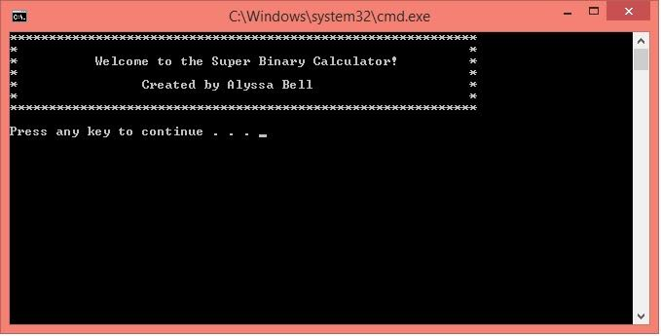

Press any key to continue to the main menu:

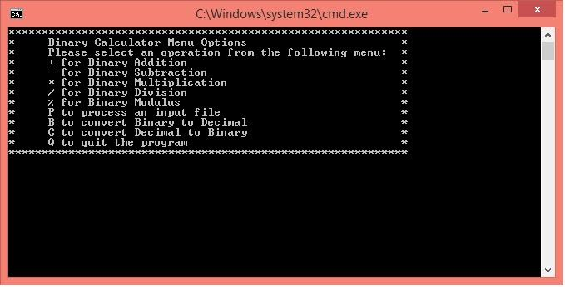

Binary Addition and Subtraction

Once in the main menu, you have the option to enter one of the operations (ex: enter “+” for addition or “P” to process files).

The addition operation allows you to input two binary numbers. Binary.cpp will perform the addition and display the binary sum. Be sure each binary number is exactly 8 characters long, otherwise an error will occur.

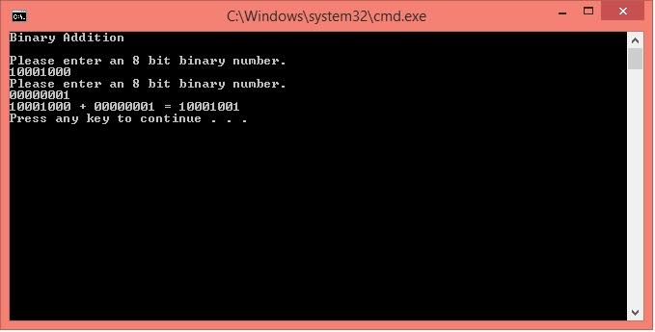

Once you have added your two binary numbers, and the result has been displayed, press any key to continue. This will bring you back to the main menu where you can perform additional operations.

To subtract in binary, enter “-“. This will bring you to the Binary Subtraction screen. Please note that any subtraction difference that equals less than 0 will display an error.

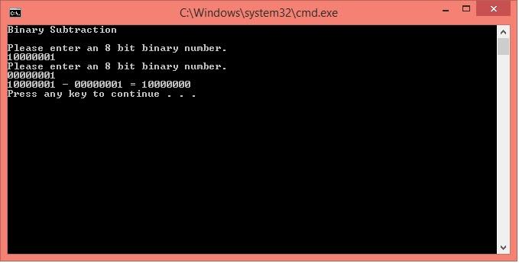

Binary Multiplication And Division

Once you’re done subtracting, you can try multiplication or division! Just like with decimal values, you cannot divide by 0 so make sure your second binary number is greater than “00000000” when performing division. If you plan to multiply by 0.. well you know what will result from that! A 0! (Since this calculator displays the result in binary, the sum will actually be “00000000”) So let’s try something other than 0. Here are some examples of binary multiplication and division.

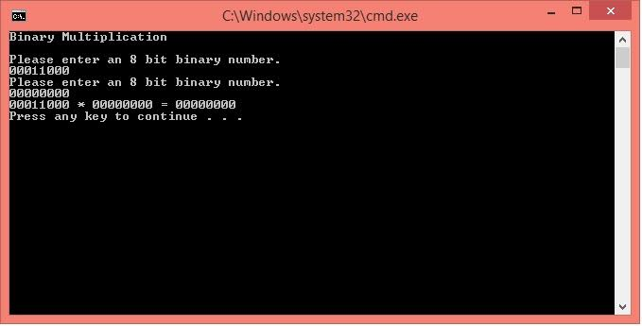

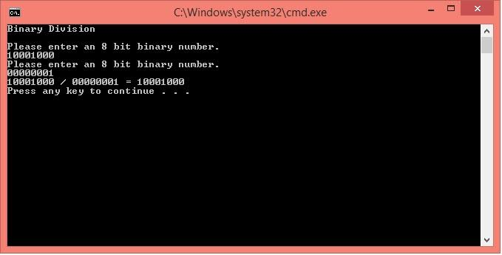

Modulus Operation

Next comes the modulo operation by entering “%”. If you are unfamiliar with this operation, it basically calculates the remainder after the second binary divides into the first binary number that you entered in. If binary #2 divides into binary #1 evenly, the result will be 0. For example, 2 goes into 4 evenly twice with a remainder of 0. However 3 goes into 5, with a remainder of 2. In base 10, this would look like 5%3 = 2. Here is an example of the modulus calculator:

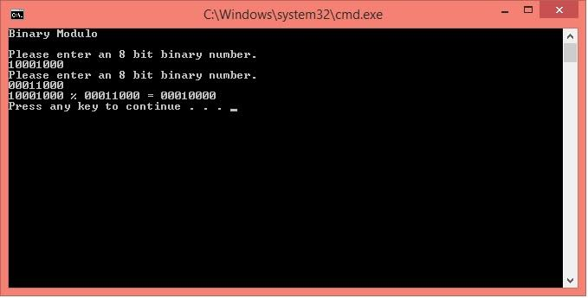

Converting To Binary And Decimal

Now that we’ve performed the different operations in binary, you can try converting a binary to a decimal or a decimal to binary by entering “B” or “C”. Remember that an 8 bit binary number must be equal to at least 0 (00000000) and no higher than 255 (11111111), otherwise an error will occur. Try entering converting different values to see what results you get!

(Convert from binary)

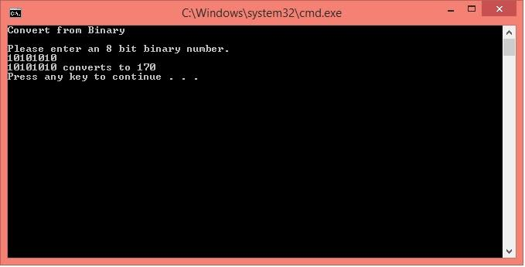

(Convert from decimal)

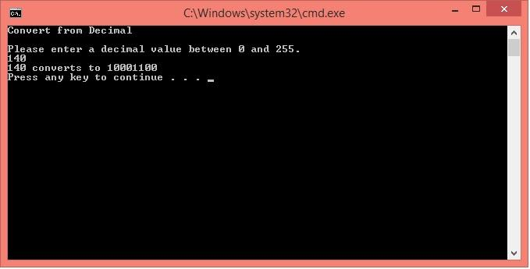

Processing Files

After you select “P”, Binary.cpp will bring you to an input screen where you can enter the name of your input file. A results file will be created for you after you enter the output file name. \*This option is strictly for performing operations on 8 bit binary numbers. Please make sure your each line of input in your file is in this format: Operator, Operand1, Operand2., If your input file does not follow this format, there will be a count of errors listed at the bottom of your output file. Once you enter the output file name in, you will be able to open your output file to see your results.

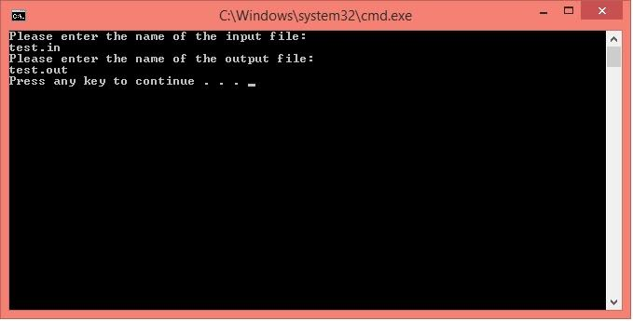

Exiting Binary.cpp

By now, you should be familiar with the program and its functions. To quit the program, enter “Q” in the main menu. This will display a tally of each operation performed, while you still have the program running. Once you hit “Q”, your screen should resemble this:

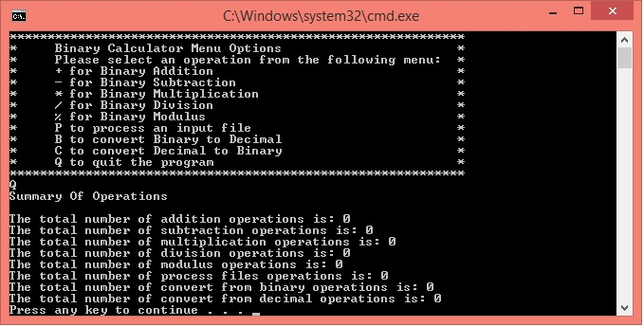

At this point, you can hit any key to continue! You have now exited Binary.cpp. I hope you found the calculator helpful!